BLACK VELVET

NUMER | ZDJĘCIE/ PICTURES |  | BLACK VELVET
/ No. | ZDJĘCIE/ PICTURES | ILOŚĆ/ QTY | BLACK VELVET
200 |  | 4800
201 |  | 2760
202 |  | 2400
203 |  | 3480
204 |  | 1560
205 |  | 3480
206 |  | 3000
207 |  | 4320
208 |  | 2400
209 |  | 2640
210 |  | 4320
211 |  | 2880
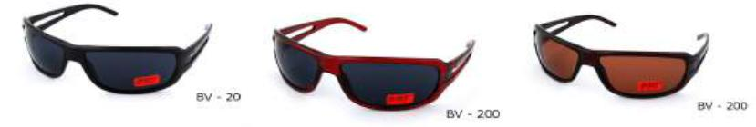
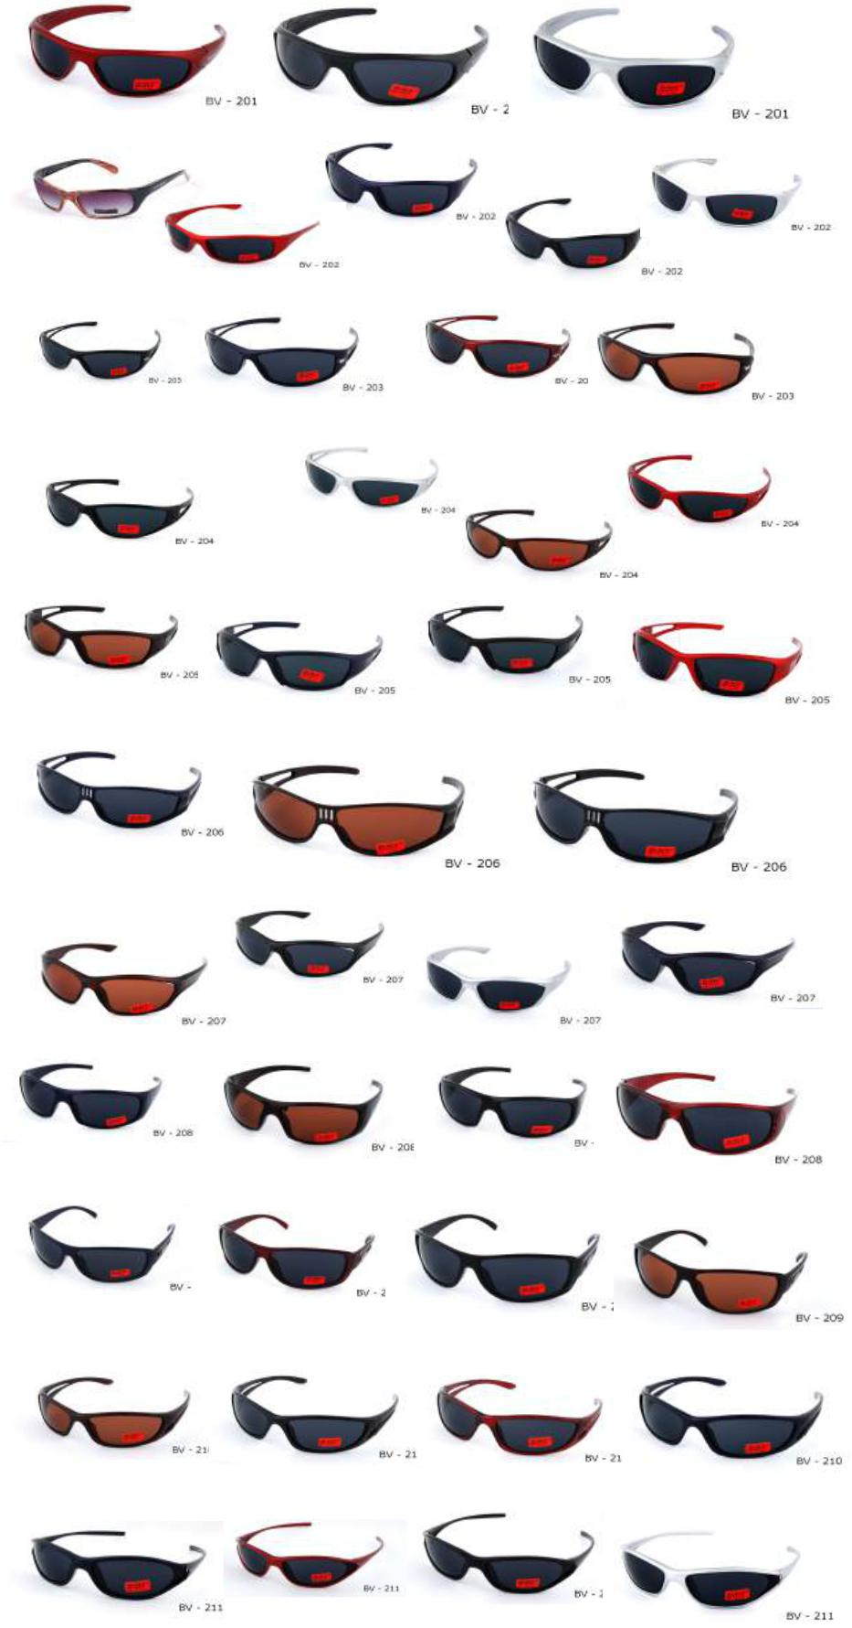

Strona 1

 |  |  | BLACK VELVET
 | 212 |  |  |  | 4200
 | 213 |  |  |  | 2400
 | 214 |  |  |  | 3120
 | 215 |  |  |  | 6960
 | 216 |  |  |  | 6960
 | 217 |  |  |  | 3960
 | 218 |  |  |  | 1440
 | 219 |  |  |  | 5400
 | 220 |  |  |  | 6360
 | 221 |  |  |  | 7200
 | 222
 |  |  |  |  | 5520
 | 223 |  |  |  | 6120
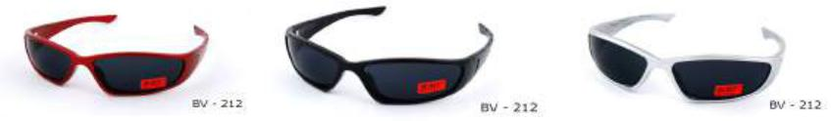
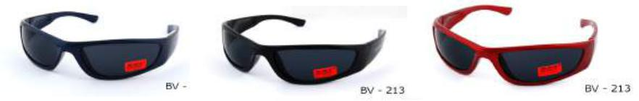
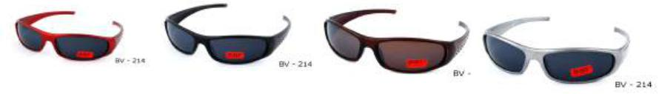
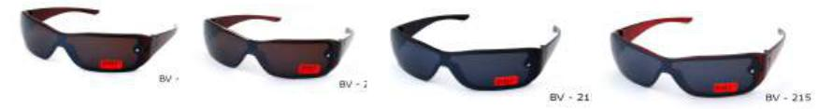
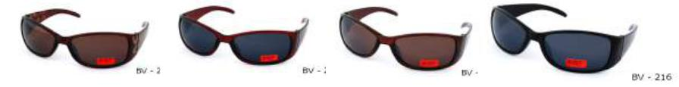
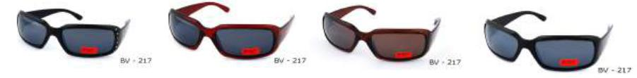
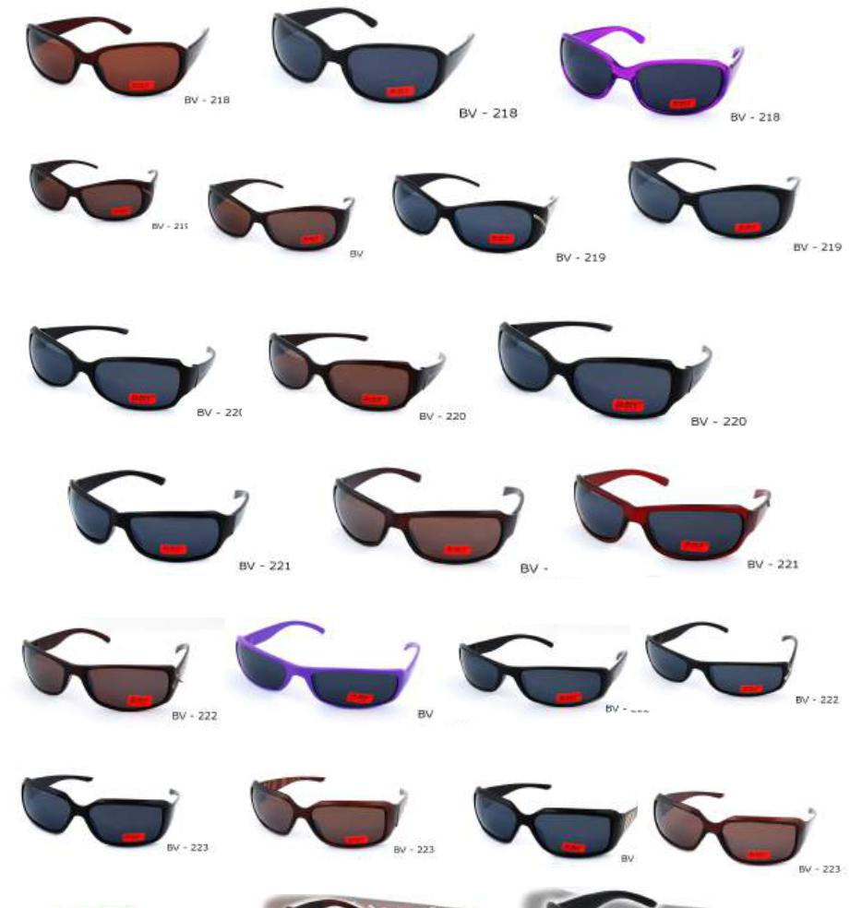

Strona 2

 | BLACK VELVET
224 |  | 4440
225 |  | 6240
226 |  | 0
227 |  | 0
228 |  | 0
229 |  | 0
230 |  | 120
231 |  | 0
232 |  | 480
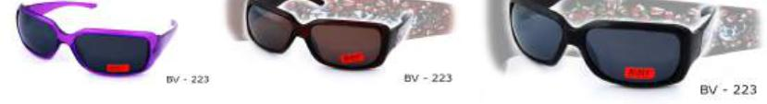
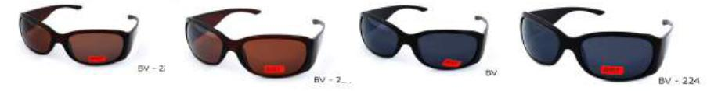
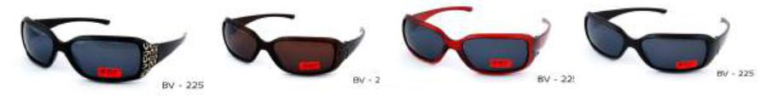
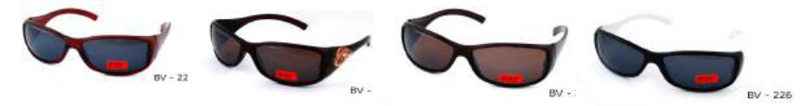
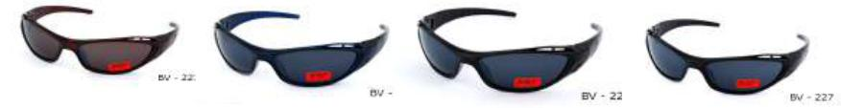
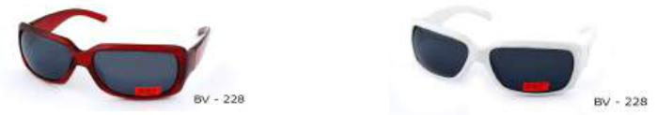
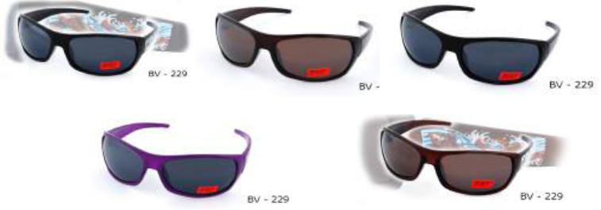
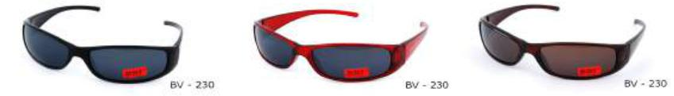
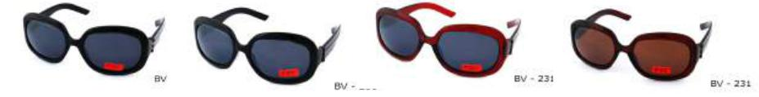
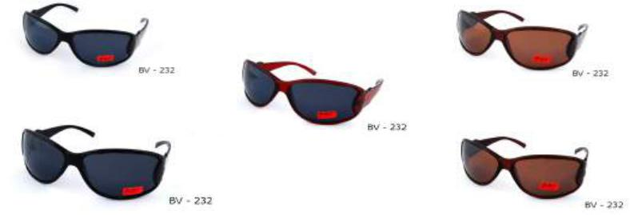

Strona 3

 | BLACK VELVET
233 |  | 360
234 |  | 480
235 |  | 600
236 |  | 0
237 |  | 600
3218 |  | 0
3224 |  | 0
3230 |  | 0
4807 |  | 0
7001 |  | 4800
7002 |  | 1800
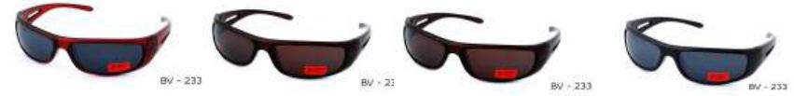
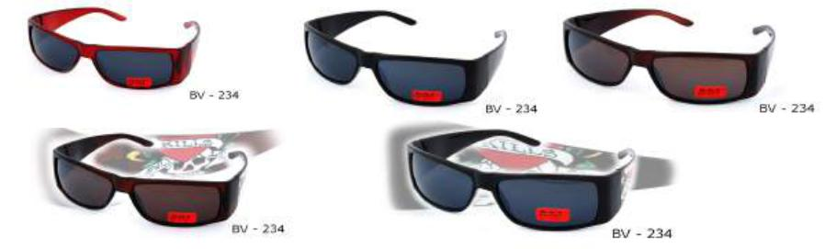
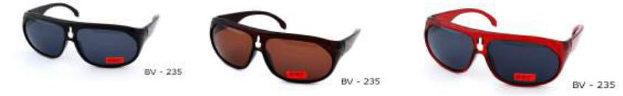
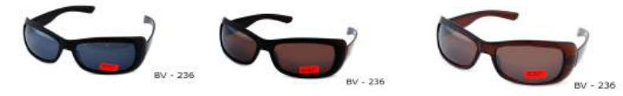
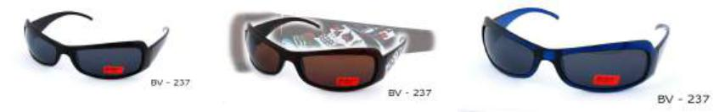
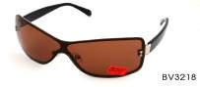
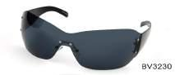
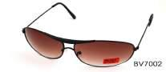
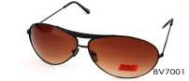

Strona 4

 | BLACK VELVET
8020 |  | 0
8403 |  | 0
8404 |  | 0
8407 |  | 0
8408 |  | 0
8413 |  | 300
8414 |  | 0
8520 |  | 300
8523 |  | 300
8525 |  | 300
8528 |  | 300
T002 |  | 1884
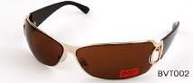
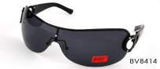
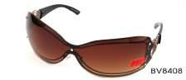
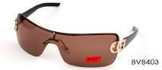

Strona 5

 | BLACK VELVET
T003 |  | 300
T004 |  | 3000
T006 |  | 1500
T007 |  | 300
T015 |  | 300
T024 |  | 300
T026 |  | 300
T033 |  | 300
T050 |  | 600
T054 |  | 300
MIX |  | 17448
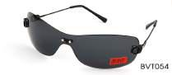
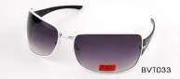
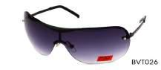
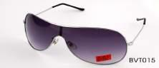
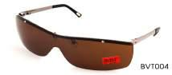
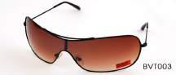

Strona 6

